Our Community Support Fund has five key themes for investment. Each of these themes is outlined below and expanded on, to show a defined list of impacts. We refer to this list as our impact framework.

When you apply for funding from Avenue Services, we will help you to review your project against our impact framework, to identify any which your project is likely achieve.

If your application to our Community Support Fund is successful, we will work with you to put simple steps in place to measure these impacts. This helps us to capture the difference our funding makes each year.

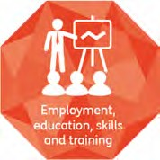
1. Employment, education, skills and training

‘We aim to support residents in developing skills and accessing training opportunities in order to enter into, and sustain, employment.’

Impact number | Impact descriptions for employment, education, skills and training
1a | People developing a new skill
1b | People accessing training
1c | People gaining an accredited qualification
1d | People entering into work
1e | People gaining work experience, including work placements and volunteering
1f | People with increased employability (moving close to work)

. ’
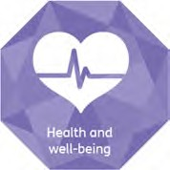
2. Health and well being

‘We aim to support residents to live happy, healthy and fulfilled lives, with access to the care and support services they need’.

Impact number | Impact descriptions for employment, education, skills and training
2a | People taking part in activities that promote physical wellbeing
2b | People reporting feelings of improved physical health
2c | People taking part in activities that promote mental wellbeing
2d | People reporting feelings of improved mental wellbeing
2e | People with increased confidence to manage their own health
2f | People supported to live more independently
2g | People supported to access specialist health services
2h | People with reduced isolation
2i | People reporting feeling more in control of life

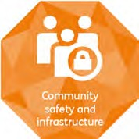
3. Community safety and infrastructure

‘We aim to ensure that our communities are safe places to live and are equipped with the infrastructure they need to shape their aims and aspirations.’

Impact number | Impact descriptions for employment, education, skills and training
3a | Community groups supported to increase community capacity
3b | People reporting increased sense of belonging to a community
3c | People reporting increased sense of safety
3d | People participating in positive active citizenship
3e | People supported to access technology


4. Environment

‘We aim to make our communities greener and cleaner places in which to live and to assist our residents to live more sustainable lifestyles.’

Impact number | Impact descriptions for employment, education, skills and training
4a | Residents actively engaged in improving spaces or places
4b | Spaces being better used by the community
4c | Green spaces improved
4d | Residents actively engaged to help them to reduce energy use in the home
4e | People reporting lifestyle changes that are more sustainable

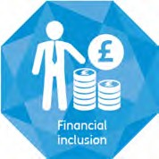
5. Financial Inclusion

‘We aim to ensure that everyone is able to access the
basic financial services products that are needed to participate
in a modern society.’

Impact number | Impact descriptions for employment, education, skills and training
5a | People accessing appropriate and impartial advice re managing money
5b | People accessing appropriate and impartial advice re financial services
5c | People with increased confidence to manage their money
5d | Amount of debt reduced
5e | Amount of increased savings

