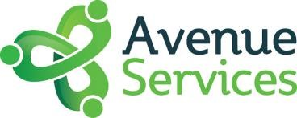
Avenue Services
Surplus Project Fund 2022/2023
Application Form

- Please provide the following details about you/your organisation:

Applicant name
Organisation name
Address
Email address
Telephone number

- What is the name of your project?

- Please provide a brief description of your project.

- Where is your project going to take place?

- When is your project going to start and end?

- Who will take part in your project and what difference will it make to them and the community?

(This should include some information about whether this was a suggestion from the community or if you are responding to a known issue in the community. Please include details of any support for this project including consultation with residents or Avenue Services staff members)

- What involvement has the community had, or will have, in the planning, design and delivery of the project?

- Please conservatively estimate the number of people your project will directly benefit.

- How will you make this project accessible?
(This could include disability access, financial accessibility, transportation, language/literacy barriers, or childcare provision).

